Sequence diagram

Iteraction between elements in the project

Dynamic behaviour of system

How to add a member or other feature we have dif interaction diagram

We refer one interaction diagerm to other like calling function to other page

Complete structure of system

Signin

Pass

Username



Comment



Author resp class object



 Message2 message1 : asyncronus



 Messege 1 message2: syncronus



Active bar

Actor is sending req for book a ticket on response the server sending some message the msg is replied by dotted arrow

Customer order actor class:Object :customer :order

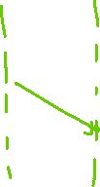

enquiry

New order order

:device :device

:decive

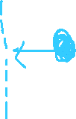

Access mike Failure worning

Self message found message lost message

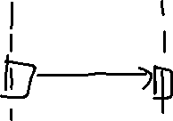

Customer Bank these are the guards

Balance

Deposit

Atm system

Sd Atm_system

Customer server



welcome

loop getBalance()



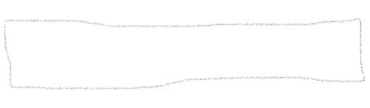 balance

opt bal >=amount



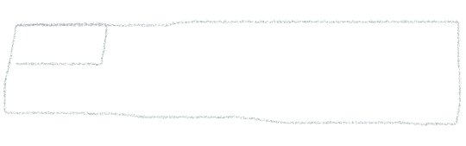 Debit()



 Balinfo()



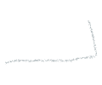 alt condition



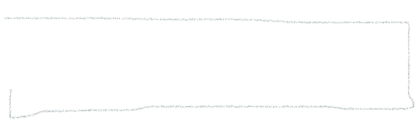

Else

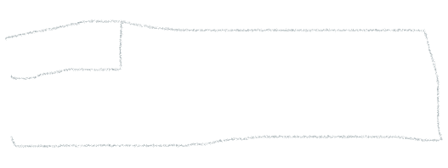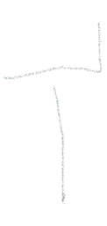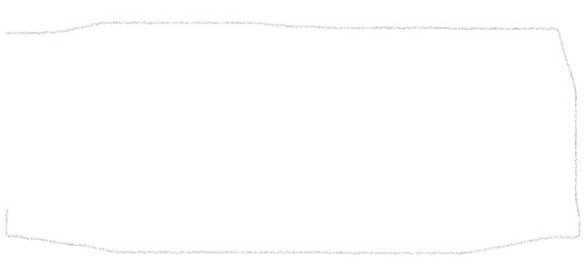

loop

alt